ONTARIO POSTERS

To make sure workers know their rights, most workplaces in Ontario must put up posters and other information.

EMPLOYMENT STANDARDS ACT  
  
All workplaces covered by the Ontario *Employment Standards Act 2000* must distribute an employment standards poster to all employees. Employers are no longer **required** to post it in the workplace. This poster:

* describes important rights and requirements under the Employment Standards Act
* must be provided to employees who are covered by the ESA [**within 30 days**](https://www.ontario.ca/laws/statute/00e41#BK2:~:text=copy%20of%20the%20poster%20within%2030%20days) of their date of hire
* is available in multiple languages upon request
* must be the most recent copy of the poster

Please see **Appendix A.**

OCCUPATIONAL HEALTH AND SAFETY ACT

All workplaces covered by the Ontario *Occupational Health and Safety Act* must put up:

* “a health and safety at work“ poster
* a copy of the Occupational Health and Safety Act (providing such information about the Act and the regulations as the Employer considers appropriate)
* the names and locations of the workplace joint health and safety committee members, if any or the health and safety representative (if applicable)

If the workplace has more than 5 regularly employed workers, the employer must also prepare, maintain and post the health and safety statement, workplace violence and workplace harassment policies - **these must be dated and signed.**  
  
The Health and Safety at Work poster:

* outlines the rights and responsibilities of workers, supervisors and employers under the Occupational Health and Safety Act
* includes a Ministry of Labour, Immigration, Training and Skills Development telephone number (1-877-202-0008) to report critical injuries, fatalities and work refusals
* can be printed in colour or black and white
* must be displayed in English and the majority language of the workplace
* must be printed on paper that is at least 8.5 × 11 inches (letter size).

Please see **Appendix B.**

WORKPLACE SAFETY INSURANCE ACT  
  
Workplaces covered by the Workplace Safety Insurance Act

Employers who are covered by the Workplace Safety and Insurance Board (WSIB) must put up:

* In case of injury poster

This poster:

* is from the Workers Safety and Insurance Board (WSIB)
* outlines the steps workers and employers need to take if there is an injury at work
* must be displayed prominently in the workplace and at each first aid station, if any

Please see **Appendix C:**ADDITIONAL POSTING REQUIREMENTS

* The “In Case of Injury” Poster (Form 82) at a first aid station and in other conspicuous place
* A copy of the Occupational Health and Safety Act and any explanatory material prepared by the Ministry, such as: "Health & Safety at Work: Prevention Starts Here” Poster
* The occupational health and safety policy
* Accurate records of the levels of biological, chemical or physical agents in the workplace (OHS Act, Sec. 26(1)(f))
* Names and work locations of the joint health and safety committee (JHSC) members, if any (OHS Act, Sec. 9(32)) or the health and safety representative (if applicable)
* JHSC meeting minutes and inspections must be posted on a health and safety board (H&S board), if applicable
* If first aid trainers are required at the workplace, their names must be posted on a health and safety board
* Annual Workplace Safety and Insurance Board (WSIB) summary, if requested from WSIB (OHS Act, Sec. 12(2))
* The workplace violence and workplace harassment policies (not required for 5 or fewer employees) (OHS Act, Sec. 32.0.1 (2))
* Any order regarding the use of biological, chemical or physical agents in the workplace (OHS Act, Sec. 33(3) and 41(3))
* Any Ministry of Labour order (OHS Act, Sec. 57(10)(a))
* A notice of compliance with an order (OHS Act, Sec. 59(3))
* Results of monitoring of airborne concentrations of a designated substance and worker exposure to airborne concentrations of a designated substance (Designated Substances Regulation, Sec. 25(a))
* Safety Data Sheets must be posted in a binder and/or near the H&S board, if any
* Emergency phone numbers and the emergency evacuation plan must be posted on the H&S board
* Accessibility Policy (AODA) and additional AODA postings depending on employer size

**APPENDIX A:**

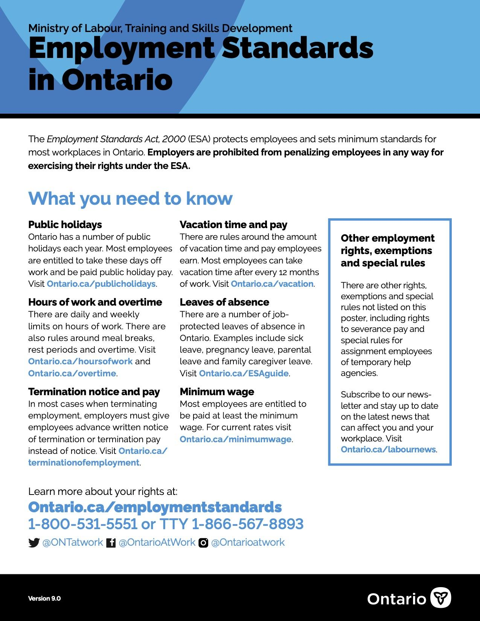  
  
  
  
**APPENDIX B:**

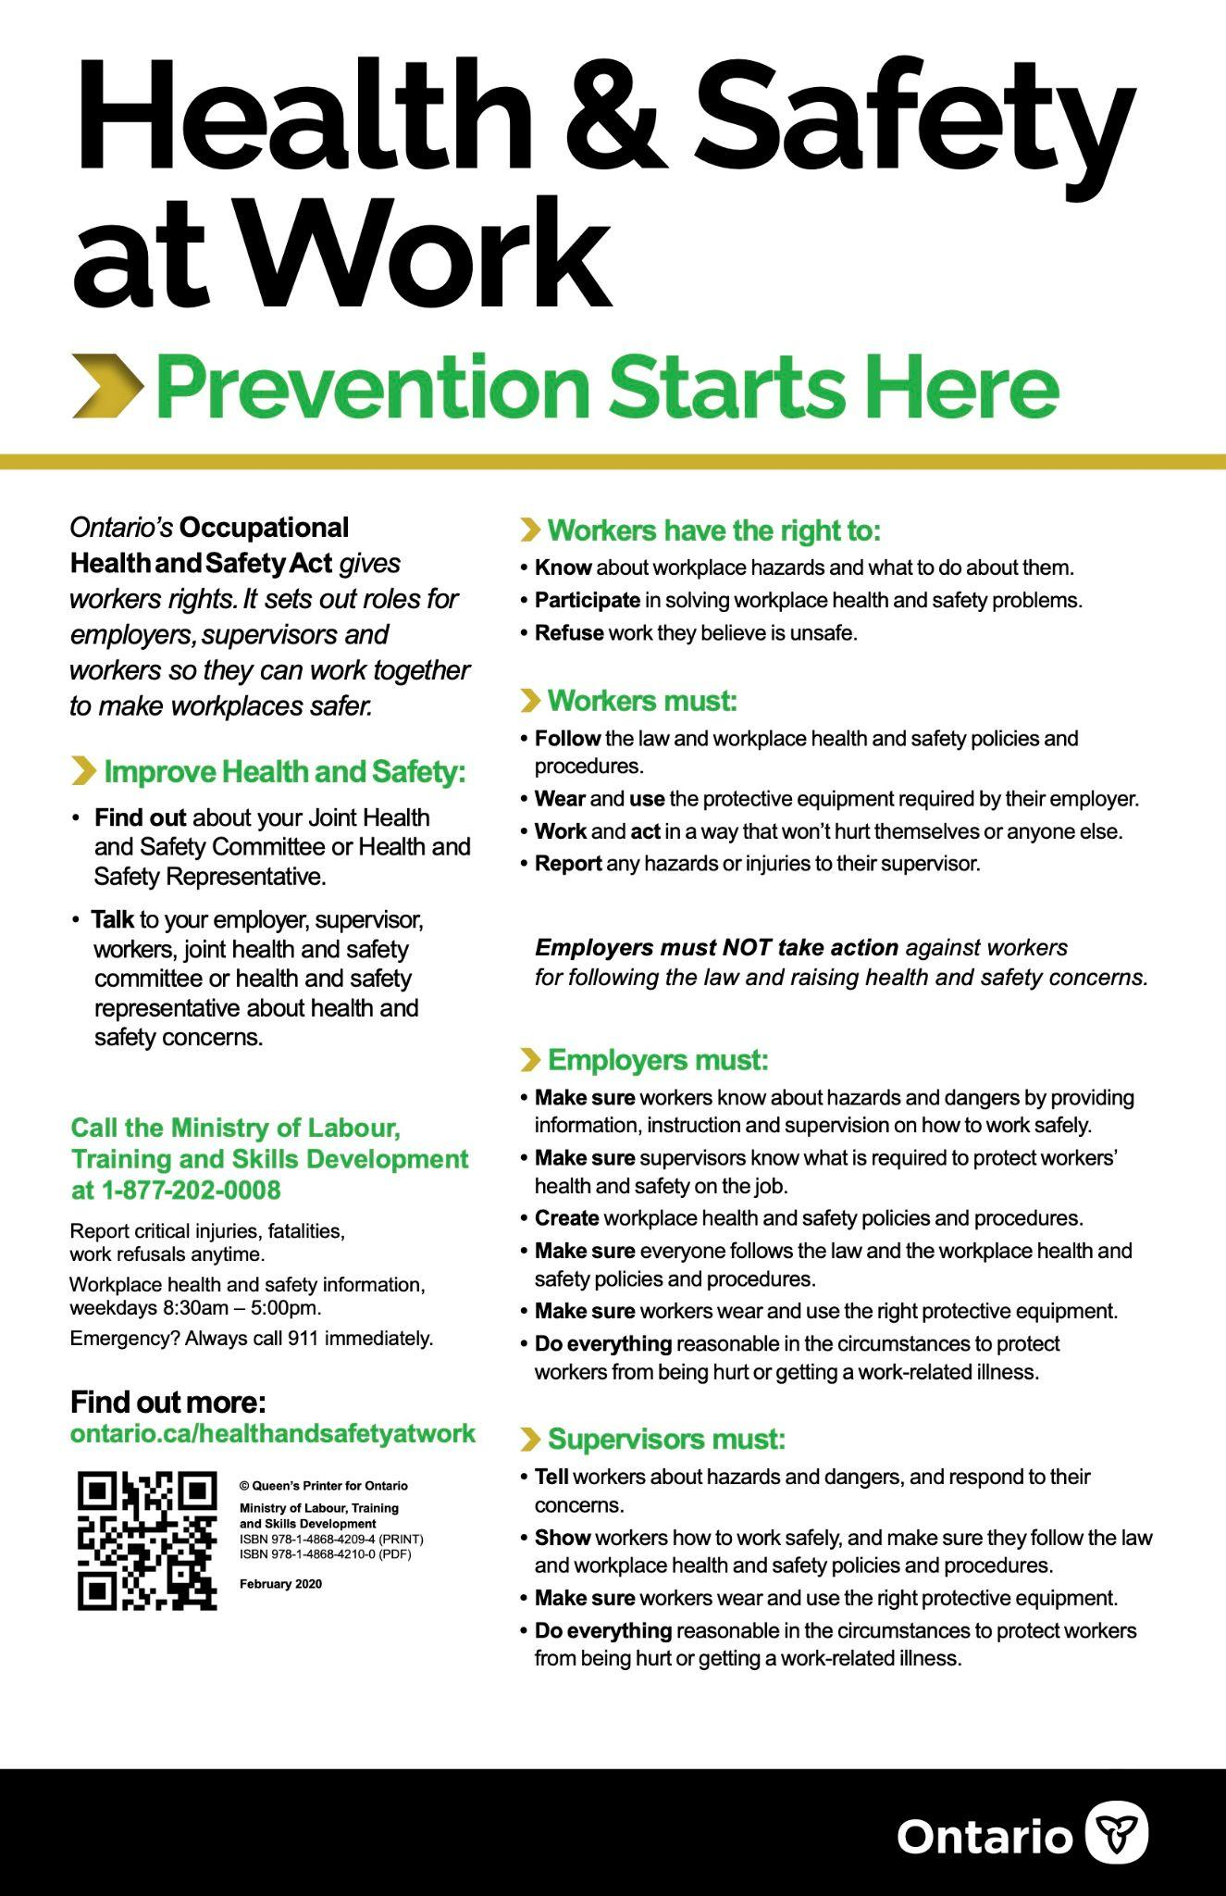

**APPENDIX C:   
